AI-Based Resume Filtering
Ankit Goel

Ankit117.be22@chitkara.edu.in

2210990117
Ankush

ankush119.be22@chitkara.edu.in

2210990119

Rao Faeez

Rao2138.be22@chitkara.edu.in

2210992138
Dr. Shikha Tuteja

Department of Computer Science & Engineering

Chitkara Institute of Engineering and technology, Chitkara University, Punjab, India

Shikha.1290@chitkara.edu.in

Dikshit Singla

dikshit284.be22@chitkara.edu.in

2210990284

Abstract:- The process of resume screening is an integral part of the recruitment process that has traditionally relied on manual screening and basic Applicant Tracking Systems (ATS). However, this process is often time-consuming and less efficient. Moreover, there is often human bias associated with resume screening. Recent developments in Artificial Intelligence (AI) and Natural Language Processing (NLP) have enabled resume screening to be automated with high accuracy levels [1], [5]. This paper proposes an Artificial Intelligence-based resume filtering system that relies on NLP and ML for resume screening. The proposed system relies on text processing techniques such as tokenization, stopword removal, and lemmatization. The system further relies on feature extraction techniques such as Term Frequency-Inverse Document Frequency (TF-IDF) [2]. The system relies on cosine similarity to ensure that resume screening is performed with high accuracy levels [3]. The proposed system has shown promising results that can improve resume screening efficiency compared to traditional keyword-based resume screening techniques..
Keywords:- Artificial Intelligence, Resume Screening, Applicant Tracking System (ATS), Natural Language Processing (NLP), Machine Learning, TF-IDF, Cosine Similarity, Text Classification

INTRODUCTION:-

In the modern competitive market, organizations face a large number of applications for each available position. Manually screening all these resumes is a tedious and time-consuming task. In this context, many organizations utilize Applicant Tracking Systems (ATS) to help them manage this task more effectively. However, traditional Applicant Tracking Systems rely on basic keyword searching, which is not sufficient to comprehend the context of the resumes and job requirements [10].

The basic keyword searching may cause highly qualified applicants to be eliminated if they do not contain the exact keywords, while less qualified applicants may pass through to the next stage. This is a key area where a more intelligent and efficient system is required to effectively comprehend and analyze the semantic meaning of resumes and job requirements.

Artificial Intelligence (AI) and Natural Language Processing (NLP) have been identified as highly efficient tools for handling unstructured data. Various techniques such as TF-IDF and machine learning classification have been widely used for document similarity and information retrieval tasks [2], [5]. Moreover, recent developments in deep learning and transformer architectures have greatly improved the understanding and analysis of unstructured data [12], [13].

The proposal of this paper is to develop an artificial intelligence-based resume filtering system that can be used as an extension of the existing ATS. This system can help to increase the efficiency and fairness of the recruitment process by automatically identifying the most suitable candidate.

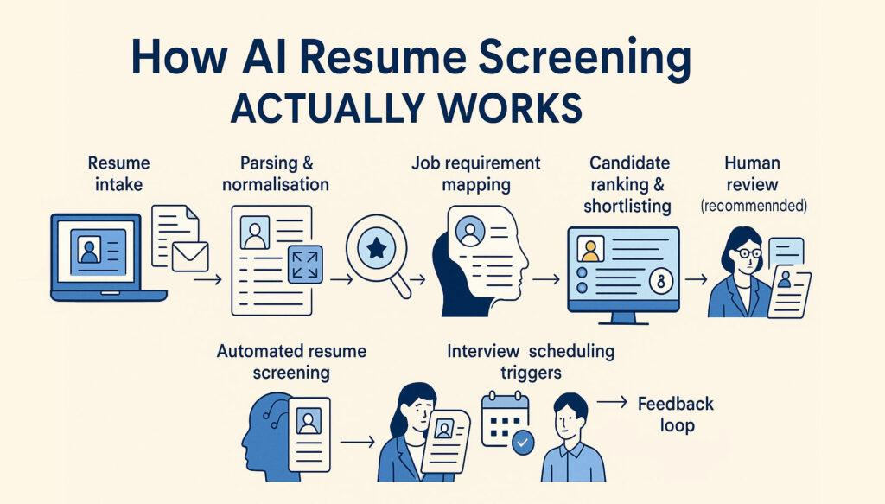

Figure 1: Workflow of AI-Based Resume Filtering in an Applicant Tracking System

LITERATURE REVIEW:-
Several researchers have worked on investigating the application of Artificial Intelligence (AI) and Natural Language Processing (NLP) in Recruitment Systems. Conventional Applicant Tracking Systems (ATS) mostly utilize keyword matching methods. These methods are found to be effective in dealing with large volumes of resumes; however, these methods do not consider the context of the applicant profiles [10].
Recently, researchers have worked towards enhancing resume screening using machine learning approaches. Term Frequency-Inverse Document Frequency (TF-IDF) is found to be highly effective in determining the weight of words in documents [2]. Similarly, cosine similarity is often used to measure the similarity between resumes and job postings in text-based systems [3].
Several researchers have also worked on developing classification models such as Naive Bayes and Support Vector Machines for text classification problems [8], [7]. These models are trained to evaluate candidates and increase the efficiency of the hiring process.
Furthermore, there have been significant advancements in deep learning techniques and transformer-based approaches such as BERT, which have improved the understanding of text-based information by establishing context-related relationships between words [13].
Despite these advancements in existing approaches, there are still various challenges associated with these approaches, such as bias in training data, limited deep semantic understanding, and limited evaluation of non-technical skills. These challenges further emphasize the need to develop advanced and intelligent approaches to improve resume filtering.

PROBLEM STATEMENT:-

The process of screening resumes is a tedious and inefficient task, especially for organizations that receive a high volume of resumes for a single job position. Conventional Applicant Tracking Systems (ATS) heavily rely on keyword-based filtering, which fails to understand the semantic meaning of resumes as well as job descriptions [10]. Therefore, the chances of qualified candidates getting eliminated from the selection process are high if the keywords are not available in the resume, while unqualified candidates might be selected for the next level of the selection process.

In addition, the conventional approaches to text classification and filtering face difficulties in semantic understanding and contextual relevance, which are critical for candidate-job matching [5]. Thus, the need for the development of an intelligent system for efficient resume screening using Artificial Intelligence and Natural Language Processing technologies.

OBJECTIVES:-

To build a system based on AI for automated resume filtering

To increase the accuracy of candidate-job fit

To minimize the effort in the hiring process

To increase the efficiency of Applicant Tracking Systems using NLP

PROPOSED SYSTEM / METHODOLOGY:-

6.1 System Overview:-

The proposed system is intended to automate the resume screening process through the use of Artificial Intelligence and Natural Language Processing techniques. The system is intended to take resumes and job descriptions as input and process them to find the best-suited candidates. First, the resume is uploaded in different formats such as PDF and DOC. The text is then extracted from the resume. The text is then preprocessed to remove noise and other unwanted information. Then, the important features are extracted and compared with the job description. Finally, the resume is ranked based on similarity.

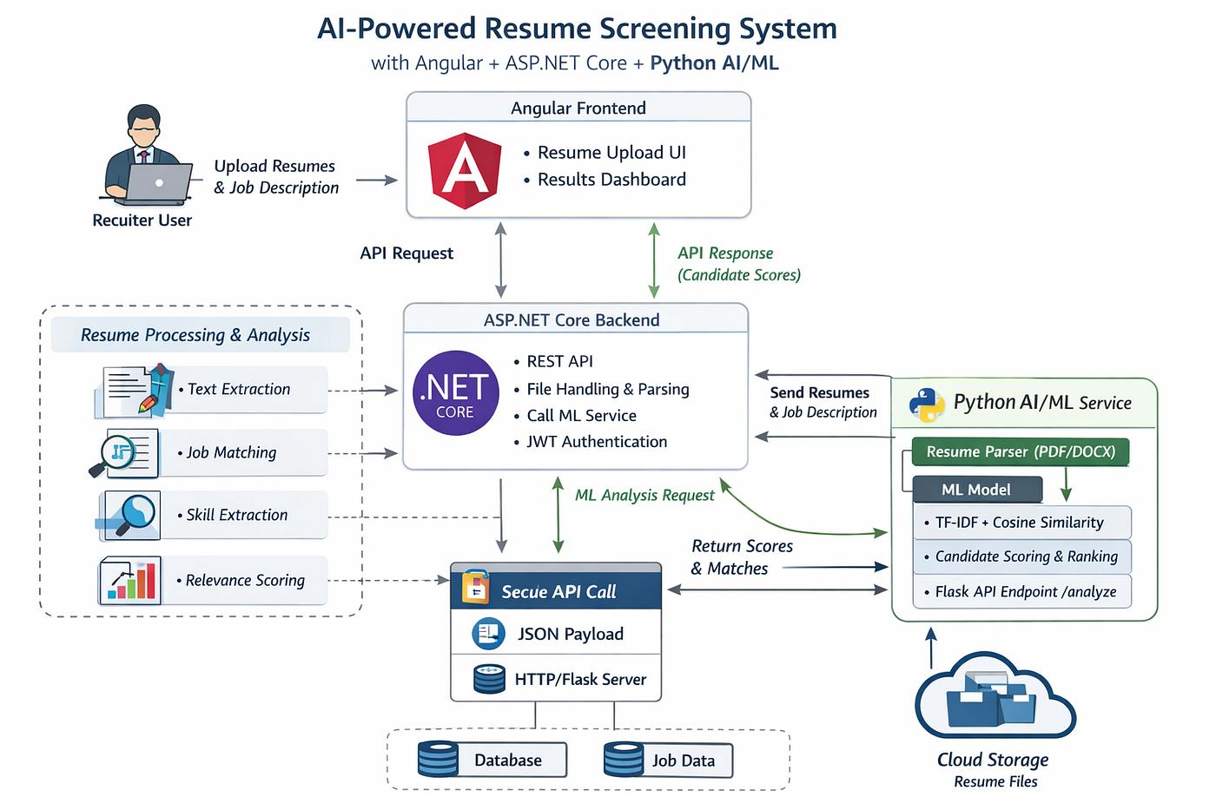

Figure 2: Architecture of AI-Based Resume Filtering System

6.2 Data Preprocessing:-

Data preprocessing is one of the key steps in the process of text analysis. It requires cleaning and transforming the raw text into a structured form. In the system, preprocessing refers to tokenization, removing stop words, and lemmatization. Tokenization refers to the division of the text into individual words. Removing stop words refers to the elimination of common words like “and,” “the,” and “is.”

6.3 Feature Extraction:-

The feature extraction process is done using the Term Frequency-Inverse Document Frequency (TF-IDF). This technique converts the text data into numerical data, which can be easily processed by the machine learning algorithm.

$$TF-IDF(t,d)=TF(t,d)×IDF(t)$$

This method highlights important words in a document while reducing the importance of commonly used words.

6.4 Similarity Measurement:-

For calculating the similarity between the resume and the job description, the cosine similarity is used. This is the measure of the angle between the two data vectors.

$$cos⁡(θ)=\frac{A⋅B}{∥A∥∥B∥}$$

The higher the cosine similarity value, the higher the similarity between the resume and the job description.

6.5 Candidate Ranking:-

The candidates are then ranked according to the similarity score in descending order. The machine learning algorithms like Naive Bayes or Logistic Regression can also be used to classify the candidates as suitable or not suitable for the job role. This helps recruiters to concentrate only on the relevant candidates.

RESULTS AND ANALYSIS:-

The performance of the proposed AI-based resume filtering system has been assessed using standard evaluation metrics. The proposed AI-based resume filtering system has been tested on the dataset of resumes and corresponding job descriptions.

The proposed AI-based resume filtering system has improved accuracy in matching the resumes with the job descriptions using the TF-IDF and cosine similarity techniques. It has been observed that the proposed AI-based resume filtering system has improved performance in matching the resumes with the job descriptions.

The performance of the proposed AI-based resume filtering system has been assessed using standard evaluation metrics like accuracy, precision, recall, and F1-score. In addition, the confusion matrix has also been generated to evaluate the performance of the proposed AI-based resume filtering system.

Accuracy Equation:-

$$Accuracy=\frac{TP+TN}{TP+TN+FP+FN}$$

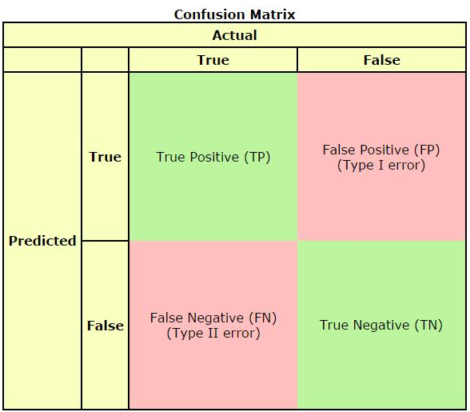

Figure 3: Confusion Matrix for Resume Classification showing True Positives (TP), True Negatives (TN), False Positives (FP), and False Negatives (FN) (Scale: Count of Predictions)

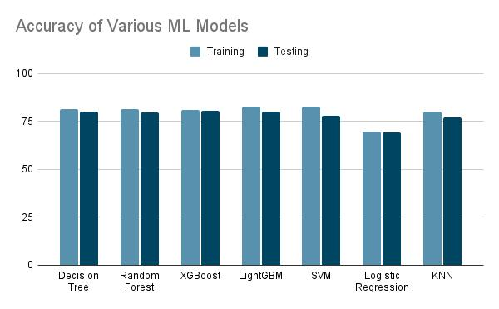

Figure 4: Accuracy Comparison of Proposed System

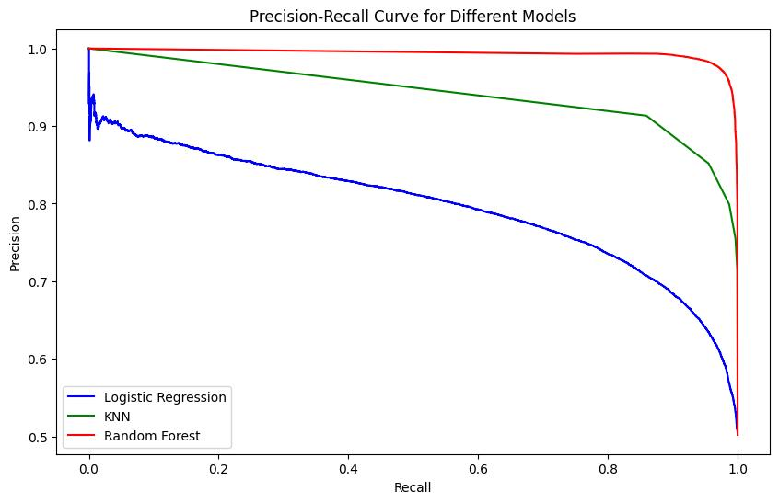
Figure 5: Precision–Recall Curve

CONCLUSION:-

The proposed AI-based resume filtering system offers a solution to the problems faced during the traditional selection process. The system, by employing Natural Language Processing and Machine Learning algorithms, can better analyze the resumes and match the candidates with the job requirements based on the relevance of the resume to the job description.

The use of TF-IDF for feature extraction and cosine similarity for measuring the similarity of the resumes with the job description improves the accuracy of the selection of the candidates. The results show that the proposed system outperforms the traditional Applicant Tracking Systems in terms of efficiency and accuracy.

The proposed system improves the selection process by offering a more reliable, efficient, and data-driven approach to resume filtering and candidate selection.

References:-

[1] S. Russell and P. Norvig, "Artificial Intelligence: A Modern Approach," 3rd ed., Prentice Hall, 2010.

[2] J. Ramos, "Using TF-IDF to Determine Word Relevance in Document Queries," Proceedings of the First Instructional Conference on Machine Learning, 2003.

[3] G. Salton and M. McGill, "Introduction to Modern Information Retrieval," McGraw-Hill, 1986.

[4] T. Mikolov et al., "Efficient Estimation of Word Representations in Vector Space," arXiv preprint arXiv:1301.3781, 2013.

[5] C. D. Manning, P. Raghavan, and H. Schütze, "Introduction to Information Retrieval," Cambridge University Press, 2008.

[6] Y. Goldberg, "A Primer on Neural Network Models for Natural Language Processing," Journal of Artificial Intelligence Research, vol. 57, pp. 345–420, 2016.

[7] T. Joachims, "Text Categorization with Support Vector Machines," Proceedings of ECML, 1998.

[8] A. McCallum and K. Nigam, "A Comparison of Event Models for Naive Bayes Text Classification," AAAI Workshop, 1998.

[9] D. Jurafsky and J. H. Martin, "Speech and Language Processing," 2nd ed., Pearson, 2009.

[10] F. Sebastiani, "Machine Learning in Automated Text Categorization," ACM Computing Surveys, vol. 34, no. 1, pp. 1–47, 2002.

[11] I. Goodfellow, Y. Bengio, and A. Courville, "Deep Learning," MIT Press, 2016.

[12] A. Vaswani et al., "Attention Is All You Need," Advances in Neural Information Processing Systems (NeurIPS), 2017.

[13] J. Devlin et al., "BERT: Pre-training of Deep Bidirectional Transformers for Language Understanding," NAACL, 2019.

[14] K. Papineni et al., "BLEU: a Method for Automatic Evaluation of Machine Translation," ACL, 2002.

[15] P. Resnik, "Using Information Content to Evaluate Semantic Similarity," IJCAI, 1995.

[16] Scikit-learn, "Machine Learning in Python," Available: https://scikit-learn.org

[17] Kaggle, "Resume Dataset for Classification and Analysis," Available: https://www.kaggle.com

[18] NLTK, "Natural Language Toolkit Documentation," Available: https://www.nltk.org

[19] SpaCy, "Industrial-Strength Natural Language Processing," Available: https://spacy.io

[20] H. Schütze, C. D. Manning, and P. Raghavan, "Introduction to Information Retrieval," Cambridge University Press, 2008.

